Question 1
The correct answers are: B, E, F
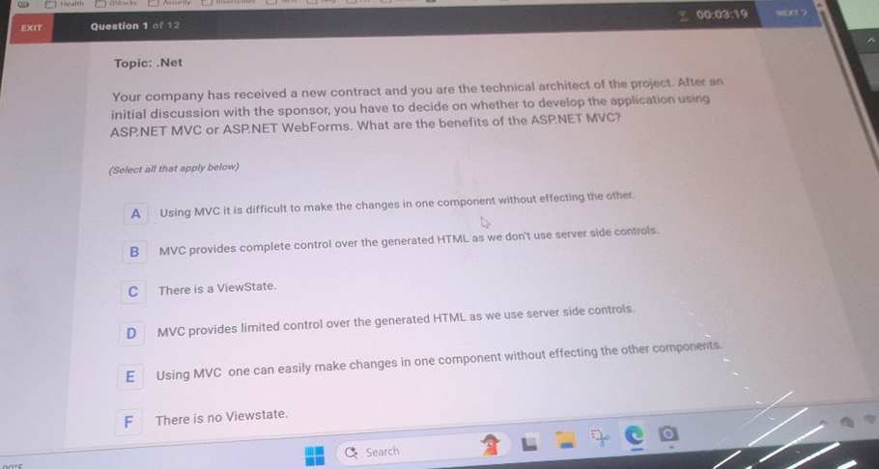

Question 2
Question 3
B and D are correct.
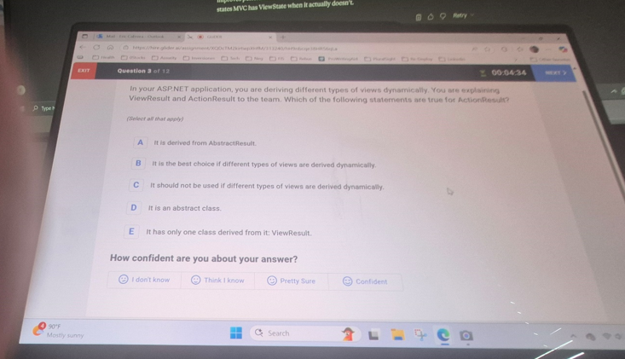

❓ Question
In your ASP.NET application, you are deriving different types of views dynamically. You are explaining ViewResult and ActionResult to the team. Which of the following statements are true for ActionResult?
(Select all that apply)
Options:
A) It is derived from AbstractResult.
B) It is the best choice if different types of views are derived dynamically.
C) It should not be used if different types of views are derived dynamically.
D) It is an abstract class.
E) It has only one class derived from it: ViewResult.

✅ Correct Analysis
- A) ❌ → ActionResult is not derived from AbstractResult. No such base class exists in ASP.NET MVC.
- B) ✅ → Correct. ActionResult is a base class for many result types (ViewResult, JsonResult, RedirectResult, FileResult, etc.), so it is the best choice when you may return different kinds of results dynamically.
- C) ❌ → Wrong. This is the opposite of the truth. If different results are needed, ActionResult should be used.
- D) ✅ → Correct. ActionResult is an abstract class in System.Web.Mvc.
- E) ❌ → Wrong. Many classes derive from ActionResult, not just ViewResult (JsonResult, RedirectResult, FileResult, etc.).

✅ Final Answer:
B and D are correct.

Would you like me to also show you a short C# code example where a controller action returns different types (ViewResult, JsonResult, etc.) via ActionResult? That would make this concept very concrete.

🔹 What is ActionResult?  - ActionResult is a base class for all action results in MVC.  - It represents the result of an action method.  - Since different actions can return different types of responses (HTML, JSON, file, redirect, etc.), ActionResult provides a flexible return type.  Think of ActionResult as a parent class.  Some common derived results:  - ViewResult → returns a view (HTML page).  - JsonResult → returns JSON data.  - RedirectResult → redirects to another URL.  - FileResult → returns a file (PDF, Excel, etc.).  - ContentResult → returns plain text.  👉 Every ViewResult is an ActionResult,  but not every ActionResult is a ViewResult. | 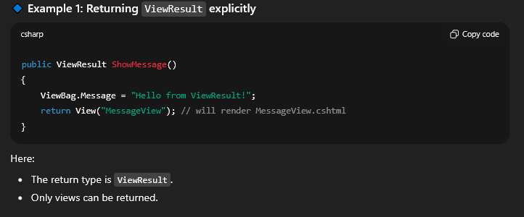
🔹 Quick Analogy:  - ActionResult = a box that can hold different result types.  - ViewResult = a specific item in the box (used to render views).  ⚡ Best Practice:  - Use ActionResult when your action may return different result types.  - Use ViewResult (or other specific results) when your action always returns one type. | 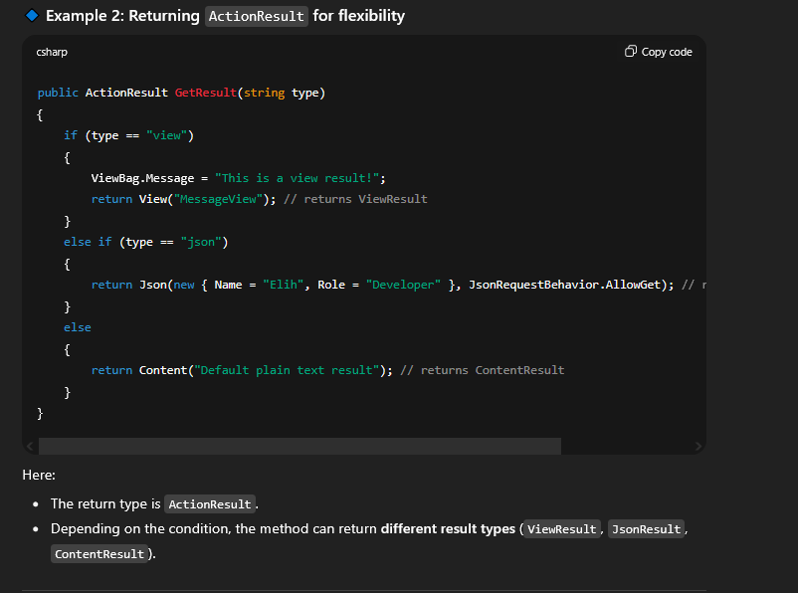

Question 4
// Choose the correct answer
using System.Reflection;
// Choose the correct answer to set to non-value
internal static Type sCType = null;
// Choose the correct answer to handle the exception
throw new ArgumentException();
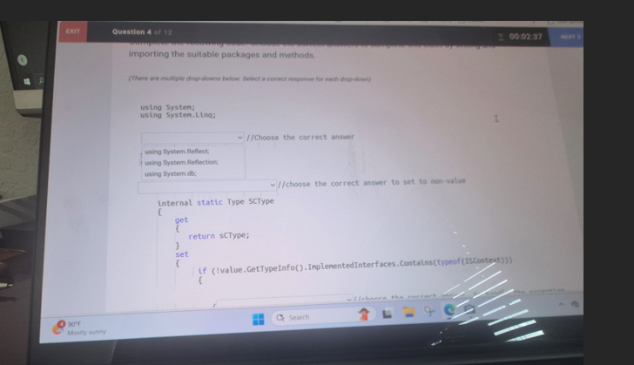
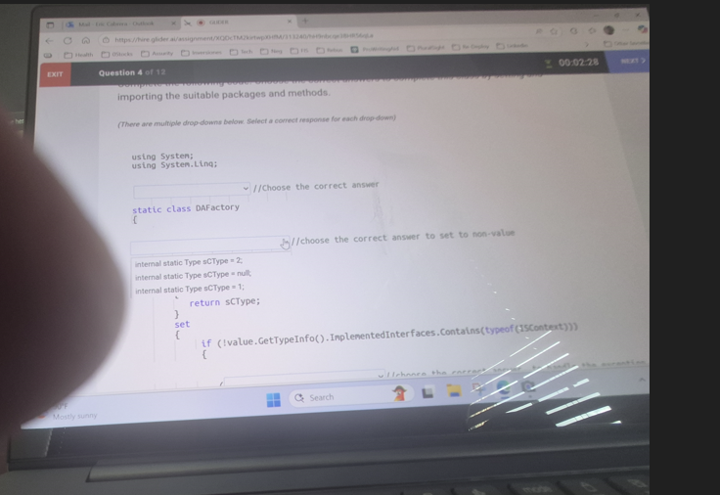
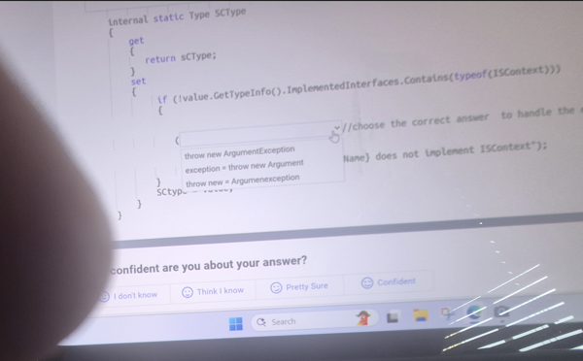

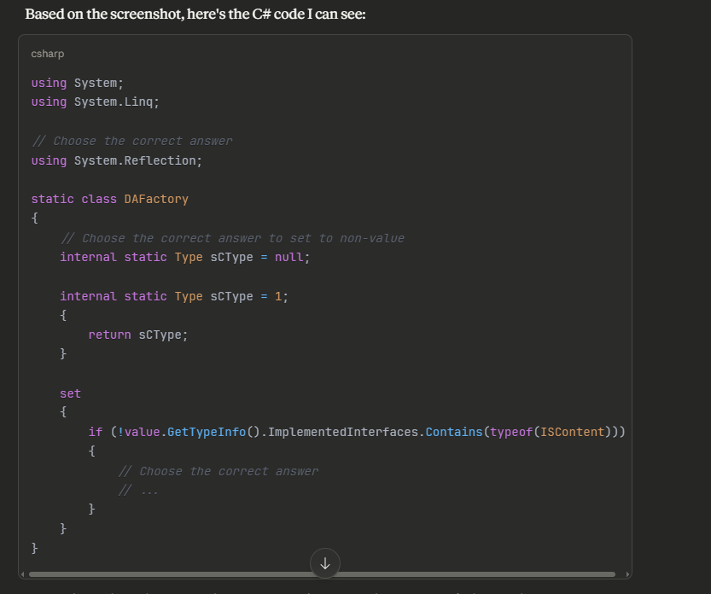

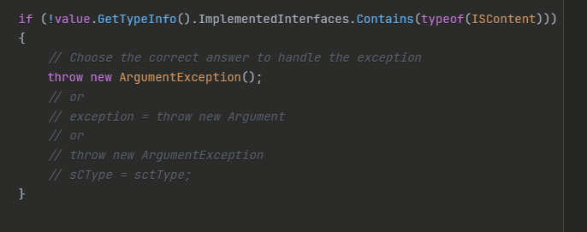
using System;
using System.Linq;

Next dropdown asks:
using System.Reflect;
using System.Reflection; //correct
using System.db;

internal static Type SCType
{
get
{
return sCType;
}
set
{
if (!value.GetTypeInfo().ImplementedInterfaces.Contains(typeof(ISContext)))
{
// choose the correct answer
}
}
}

Beginner-Friendly Explanation:  - Interface (ISContext): Think of it like a "rulebook" — any class claiming to follow it must implement certain methods or properties.  - Type: Represents information about a class, struct, or interface at runtime.  - Property with getter/setter: Allows controlled access to a variable, so you can add checks before changing its value.  - Reflection (GetTypeInfo): Lets you inspect a type while the program is running — for example, to see what interfaces it implements.  - Exception: Stops the program if someone tries to assign a type that doesn't follow the rules.  This pattern is often used to ensure only valid types are assigned, which prevents bugs and keeps your program safe.  If you want, I can make a visual diagram showing how SCType works step by step — it’s great for beginners to understand properties + interfaces + reflection. Do you want me to do that? | 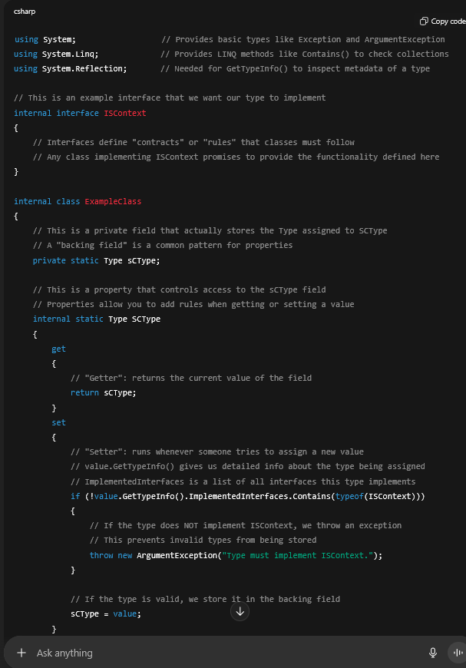
Question 12
B. Anonymous
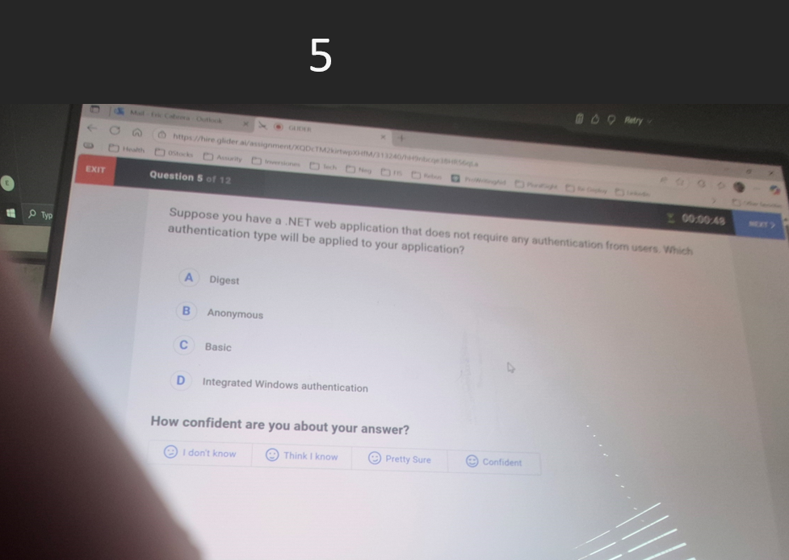
Question 5 of 12
Suppose you have a .NET web application that does not require any authentication from users. Which authentication type will be applied to your application?
A. Digest
B. Anonymous
C. Basic
D. Integrated Windows authentication
The correct answer is: B. Anonymous
Explanation:
When a .NET web application does not require any authentication from users, Anonymous authentication is used. This allows users to access the application without providing any credentials or going through any authentication process. Anonymous authentication is the default choice for public-facing applications where no user identification is needed.
Question 6
✅ Correct Answers: B and D
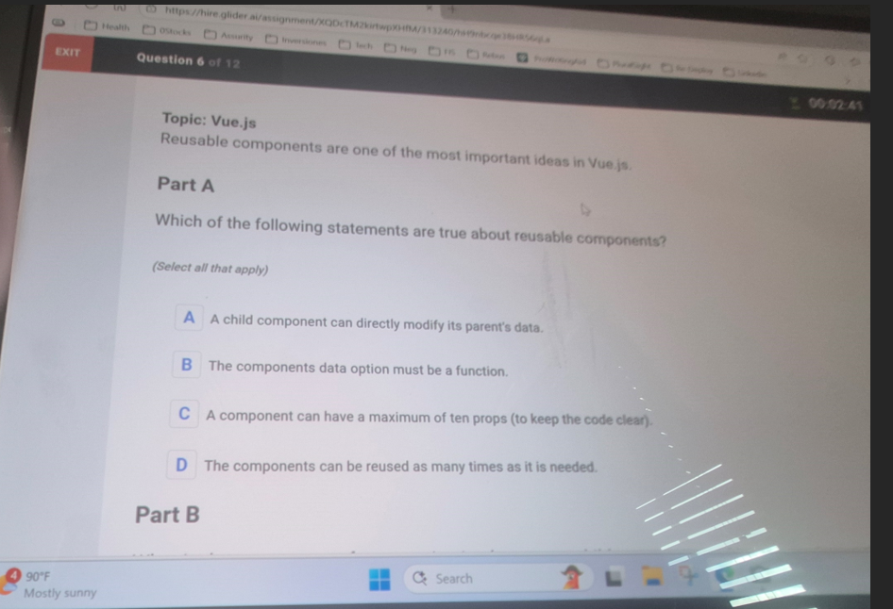
C - The parent component should listen to the child's data changes using listeners.
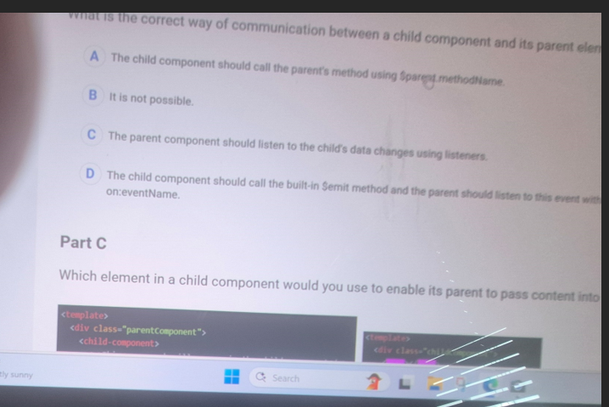

The correct answer is: <slot></slot>
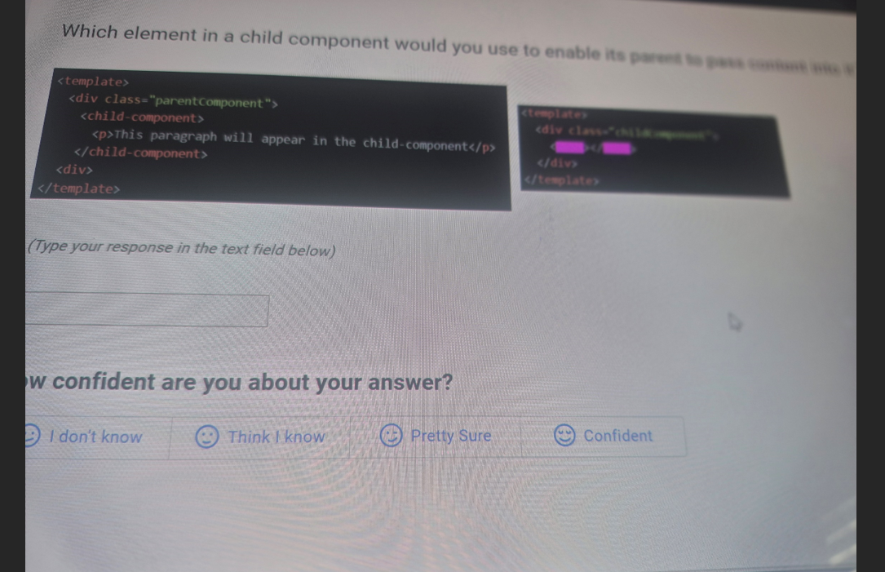

Question 6 of 12
Topic: Vue.js
Reusable components are one of the most important ideas in Vue.js
Part A
Which of the following statements are true about reusable components?
(Select all that apply)
- A child component can directly modify its parent's data.
In Vue.js, a child cannot directly modify a parent’s data. Communication from child → parent should happen via events ($emit) or a shared store (like Vuex).
- The components data option must be a function.
True.
For reusable components, data must be a function that returns an object. This ensures each instance of the component gets its own independent data.
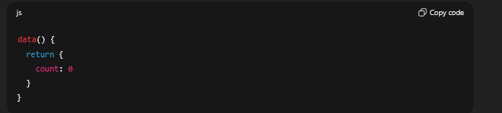

- A component can have a maximum of ten props (to keep the code clear).
❌ False.
There is no hard limit on the number of props. While keeping it manageable is a good practice, Vue doesn’t enforce a maximum.

- The components can be reused as many times as it is needed.
✅ True.
That’s the main idea of reusable components — you can instantiate them multiple times anywhere in your app.

[Content appears to be cut off in the image]
The correct answers for Part A are: B, D
Explanation:
- Option B is correct: In Vue.js, the data option must be a function that returns an object to ensure each component instance maintains its own isolated data scope
- Option D is correct: Components are designed to be reusable and can be used as many times as needed throughout an application
Options A and C are incorrect:
- A is wrong because child components should not directly modify parent data (violates one-way data flow)
- C is wrong because there's no maximum limit of ten props - components can have as many props as needed

Part b
Looking at this multiple choice question about communication between child and parent components, the correct answer is C - The parent component should listen to the child's data changes using listeners.
In modern frontend frameworks (like React, Vue, Angular), the standard pattern for child-to-parent communication is:
- Props down, events up - Parents pass data to children via props, and children communicate back to parents through events/callbacks
- Event-driven communication - Child components emit events when they need to send data or notify the parent of changes, and parent components listen for these events
The other options are incorrect because:
- A: Using $parent references creates tight coupling and breaks encapsulation
- B: Child-to-parent communication is definitely possible and commonly needed
- D: While some frameworks have built-in event systems, the general principle is about the parent listening to child events, not specifically about $emit methods
The event listener pattern maintains proper separation of concerns and makes components more reusable and maintainable.
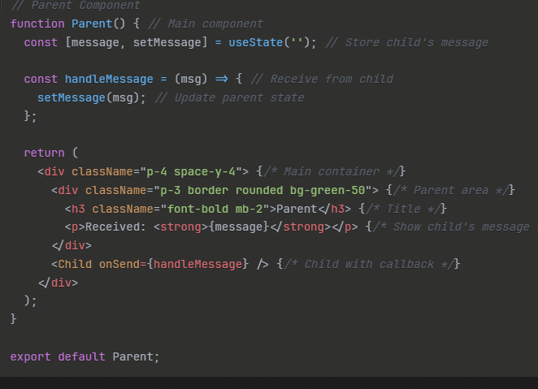 | 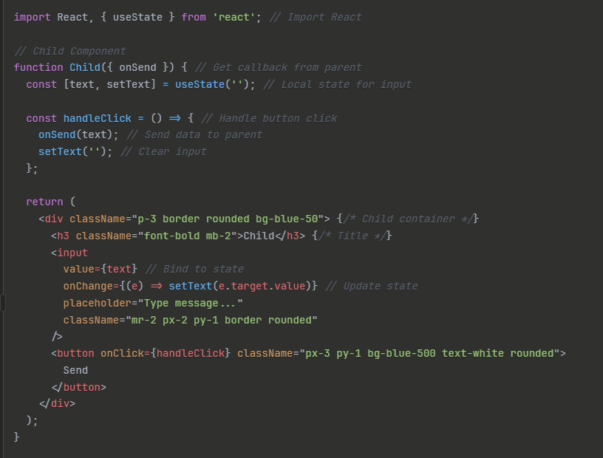

Part c
Which element in a child component would you use to enable its parent to pass content into it?
Parent | child-component
<template>  <div class="parentComponent">  <child-component>  <p>This paragraph will appear in the child-component</p>  </child-component>  </div>  </template> | <template>  <div class="childComponent">  [?] [?]  </div>  </template>
(Type your response in the text field below)
The correct answer is: <slot></slot>
Explanation:
The <slot> element in Vue.js is used to enable content projection from parent to child components. It acts as a placeholder where the parent component can insert content. In this case, the <p>This paragraph will appear in the child-component</p> from the parent will be rendered where the <slot></slot> is placed in the child component template.

Question 12
✅ Correct Answer: A
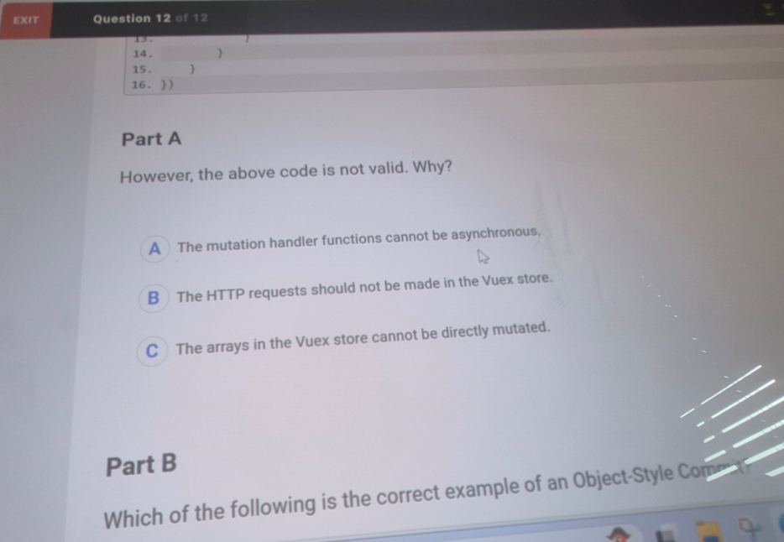
Perfect — now I can see the multiple-choice part.
The question is:
“However, the above code is not valid. Why?”
Options:
A) The mutation handler functions cannot be asynchronous.
B) The HTTP requests should not be made in the Vuex store.
C) The arrays in the Vuex store cannot be directly mutated.

✅ Correct Answer: A
The mutation handler functions cannot be asynchronous.
Why not the others?
- B is wrong → You can make HTTP requests in the Vuex store, but they must go in actions, not mutations.
- C is wrong → You can directly mutate arrays/objects inside Vuex state (mutations are supposed to do that).

🔹 What is a mutation handler function?  In Vuex (Vue’s state management library), a mutation handler function is the function you define inside the mutations object of the store.  Its job is to synchronously modify (mutate) the state.  Mutations always take state as the first argument and optionally a payload as the second.  They must not be asynchronous (e.g., await, setTimeout, API calls).  That’s why the correct answer is A — mutations must be synchronous so Vuex can properly record state changes for features like debugging and time-travel devtools. | 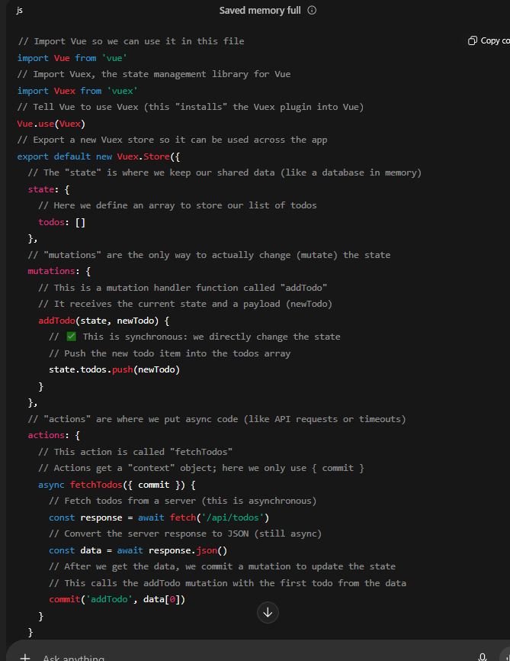

✅ Correct Answer: C
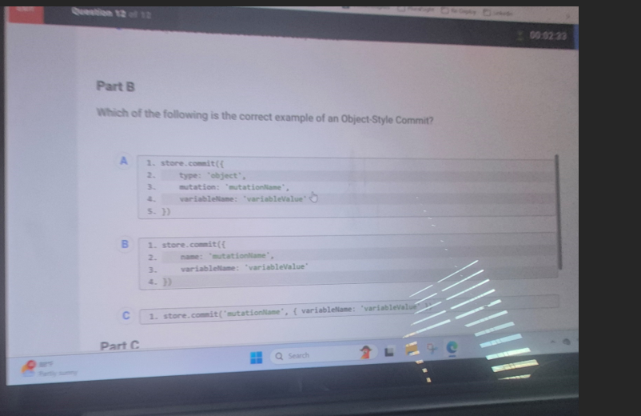

PART B
✅ Correct Answer: C
Here’s why:
- Object-style commit means you pass an object where the key is type (the mutation name), along with payload.
Example:
- store.commit({
- type: 'mutationName',
- variableName: 'variableValue'
- })
- C is actually the normal style commit (string + payload).
- But in your screenshot, A is incorrect because it uses type: 'object' (wrong, should be type: 'mutationName').
- B is incorrect because it uses name instead of type.
So the correct Object-Style Commit is actually the form of A but written correctly.
The real correct syntax should be:
store.commit({
type: 'mutationName',
variableName: 'variableValue'
})
Two ways to commit a mutation in Vuex  1. Normal Style (String + Payload)  This is the most common way.  You pass the mutation name as a string, and optionally a payload. | 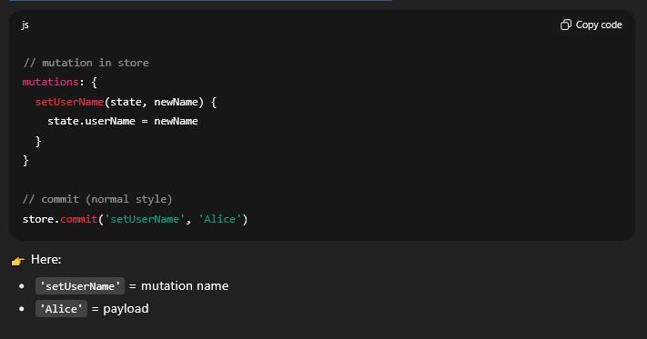
2. Object-Style Commit  Instead of passing two arguments, you pass one object.  That object must have a type property (the mutation name), and any other properties are treated as payload. | 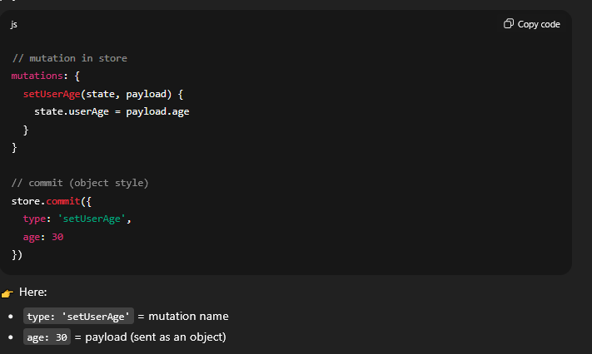

✅ Correct Answer: A) dispatch
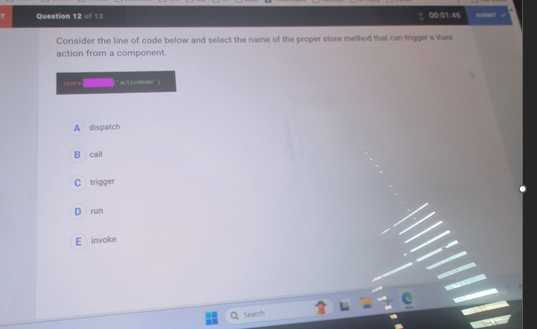
Got it — this is Part C.
The question is:
“Consider the line of code below and select the name of the proper store method that can trigger a Vuex action from a component.”
$store.______('actionName')
Options:
A) dispatch
B) call
C) trigger
D) run
E) invoke

✅ Correct Answer: A) dispatch
- To commit mutations, you use:
- store.commit('mutationName')
- To dispatch actions, you use:
- store.dispatch('actionName')
So the proper method to trigger an action is dispatch.

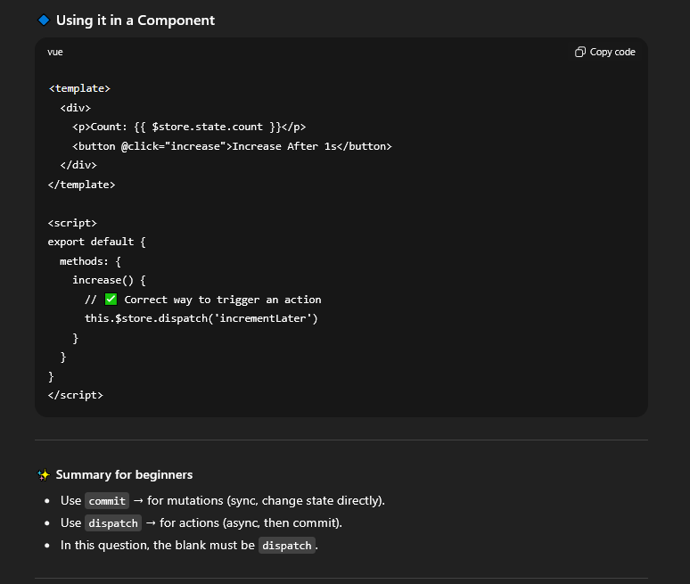 | 